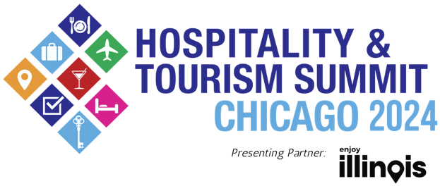
Media Contact:
Acasia Gibson / Nick Harkin
Carol Fox & Associates
acasiag@carolfoxassociates.com /
nickh@carolfoxassociates.com
708-543-9884 / 773-329-1496
For images and b-roll, click here

FOR IMMEDIATE RELEASE: March 27, 2024

2024 HOSPITALITY AND TOURISM SUMMIT CHICAGO EDUCATIONAL SESSIONS FOCUS ON INDUSTRY GROWTH AND TOURISM AND EVENT TRENDS
Keynote and Breakout Sessions Feature Industry Leaders from Choose Chicago, Illinois Office of Tourism and Chicago Department of Cultural Affairs and Special Events, Among Others
CHICAGO- Today, Ateema Media & Marketing announced the educational sessions for the Hospitality & Tourism Summit Chicago, presenting partner, Illinois Office of Tourism. The Hospitality and Tourism Summit will take place at Navy Pier’s Aon Grand Ballroom on Tuesday, April 30, with educational sessions happening from 10 a.m. to 2 p.m. Tickets are now on sale.

Educational session topics will focus on Chicago’s tourism and events industries -- capitalizing on Chicago’s unique events and attractions, and encouraging regional, national and international travel. Educational session attendance provides meeting planners with continuing education credits towards a certified meeting professional (CMP) certification.

“Beyond the remarkable networking opportunities that take place at the Hospitality and Tourism Summit Chicago, our educational panels and presentations offer attendees diverse insights into our wide-ranging industry,” said Tim O’Malley, chief executive officer of Ateema Media & Marketing. "This year's lineup is tailored to empower Chicago's hospitality, event and travel professionals with important information they need to be successful."

The keynote discussion, The State of Hospitality, Events and Tourism in Chicago, will be presented by Choose Chicago. Panelists include Choose Chicago’s Interim CEO Rich Gamble, Illinois Office of Tourism’s Daniel Thomas, Navy Pier CEO Marilynn Gardner and Illinois Hotel & Lodging Association President and CEO Michael Jacobson.
The full educational sessions agenda is as follows, culminating in the keynote panel at 2 p.m.:

- 10:30 a.m.: Working with Influencers to Tell Your Story
- 11:00 a.m.: Cutting Through the Clutter: How to Get Noticed by National Media
- 11:40 a.m.: Sustainable Event Ideas: Making It Affordable, Accessible and Practical
- 12:05 p.m.: The 77: Chicago’s Neighborhoods as Cultural Tourism and Event Destinations
- 12:25 p.m.: Unique Tourism and Event Experiences Beyond Chicago
- 1:00 p.m.: Hotel Concierge Update
- 1:05 p.m.: The Future of Tourism in Illinois: From Regional Meetings and Events to International Visitors and Everything in Between

To learn more about the educational panels, visit htsc.co/educational-sessions.

The Hospitality and Tourism Summit is nominated as the Best Fair/Outdoor Event for the 2024 ILEA Spark Awards. The Hospitality and Tourism Summit Chicago is still accepting exhibitor applications until April 1. To learn more about exhibitor benefits, visit htsc.co/exhibitor-options. Tickets are now on sale, with special pricing for various industry professionals as well as the general public. Ticket prices range from $20 to $150. To learn more about the 2024 Hospitality & Tourism Summit Chicago or purchase tickets, visit htsc.co.

# # #

About Hospitality and Tourism Summit
The Hospitality & Tourism Summit Chicago, presenting partner, Illinois Office of Tourism, is an industry conference featuring a trade show, educational sessions, and networking opportunities. The Hospitality & Tourism Summit Chicago welcomes more than 1,250 meeting and event planners, concierges, hotel salespeople, social media influencers, business representatives and industry professionals to connect, learn, and build business before Chicago’s busy tourist season.

About Ateema Media & Marketing
Founded in 2001, Ateema helps small- and mid-sized hospitality businesses thrive with local, tourism, and event marketing. Ateema Media & Marketing is a Chicago-based company that connects buyers with sellers in tourism, meetings, and events. Ateema has an array of products and services designed to help our tourism and group meetings and events-related customers attract business from meeting and event planners, visitors, concierge, social media influencers, and groups.

Ateema Media & Marketing’s portfolio includes a highly successful digital advertising platform, a visitor content marketing program, and a weekly newsletter about things to do in Chicago. Ateema produces the only visitor publication in hotels, Concierge Preferred Magazine along with The Hospitality & Tourism Summit Chicago, Faces of Chicago Hospitality, and Chicago Neighborhood Hotel Maps. Ateema Media & Marketing also provides a plethora of digital marketing services, research, and marketing services around the concierge community. For more information about Ateema, visit Ateema.com.

