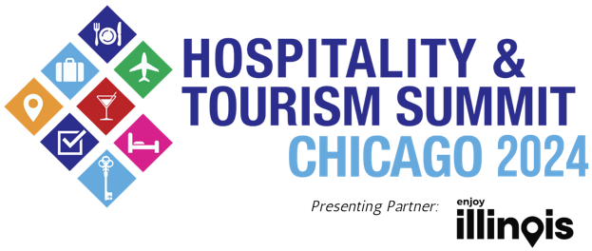
Media Contact:
Acasia Gibson / Nick Harkin
Carol Fox & Associates
acasiag@carolfoxassociates.com /
nickh@carolfoxassociates.com
708-543-9884 / 773-329-1496
For images and b-roll, click here

FOR IMMEDIATE RELEASE: Feb. 29, 2024

23RD ANNUAL HOSPITALITY & TOURISM SUMMIT CHICAGO, PRESENTED BY ILLINOIS OFFICE OF TOURISM, HOSTED BY ATEEMA MEDIA & MARKETING, RETURNS TO NAVY PIER TUESDAY, APRIL 30

One-Day Event Features More than 110 Exhibitors, Tremendous Networking Opportunities and Informative Educational Presentations from Leading Tourism and Marketing Professionals from the Illinois Office of Tourism, Choose Chicago and More

Tickets for the 2024 Hospitality & Tourism Summit Chicago On Sale Now

CHICAGO – Today, Ateema Media & Marketing announced the Hospitality & Tourism Summit Chicago, presenting partner, Illinois Office of Tourism, will return to Navy Pier’s Aon Grand Ballroom on Tuesday, April 30, from 10 a.m. to 7 p.m. Attended by over 1,250 leading industry professionals from across the Midwest, the event kicks off with educational sessions discussing industry trends, insights, and marketing tips beginning at 10 a.m.; a “who’s who” trade show of exhibitors from 2 to 7 p.m. and a special networking happy hour on the show floor from 5:30 to 7 p.m. Highlights include a panel discussion. presented by Choose Chicago, addressing The State of Hospitality, Events and Tourism in Chicago, featuring Choose Chicago’s Interim CEO Rich Gamble, Illinois Office of Tourism’s Daniel Thomas, Navy Pier CEO Marilynn Gardner and Illinois Hotel & Lodging Association President and CEO Michael Jacobson.

“Chicago’s hospitality, tourism and events industry gathers annually at this event to learn, showcase their companies, share their experiences, build their businesses, find new venues and vendors, and enhance their networks,” said Tim O’Malley, chief executive officer of Ateema Media & Marketing. “We are also thrilled to welcome the partnership of Illinois Office of Tourism to strengthen this year’s educational content. Attendees are also treated to some of the best culinary, entertainment and experiential attractions, which is what makes the Hospitality & Tourism Summit Chicago a landmark event in our industry’s calendar, as well as a primer for anyone interested in learning about the diverse tourism and event offerings that our city offers.”

This event attracts over 1,250 top professionals, including meeting and event planners, concierges, hotel salespeople, destination management companies (DMCs), press, social media influencers, business representatives and industry experts to network while experiencing some of Chicago’s top attractions, cultural institutions, hotels and dining, as well as neighborhood organizations and regional destinations. Exhibitors showcase from across Chicago’s 77 vibrant neighborhoods, including Big Bus Tours, FlyOver Chicago, Museum of Contemporary Art Chicago, Navy Pier, Starbucks Reserve Roastery Chicago and The Second City. A full list of exhibitors can be found at htsc.co/2024exhibitors.

The full program will be announced in March, but attendees can expect to enjoy food and drink samples from local restaurants and nightspots, interact with new and established venues and attractions, and learn from industry leaders about the tourism and hospitality sectors.

Additional educational sessions will include a cutting-edge session on meeting and event sustainability for meeting and event planners and DMCs, an overview of the Illinois Office of Tourism's plans and other sessions on tourism and events in Chicago's neighborhoods and in the neighboring regions.
There are varying ticket levels and ticket prices range from $20 to $150. To learn more about the 2024 Hospitality & Tourism Summit Chicago or purchase tickets, visit htsc.co.

# # #

About Hospitality and Tourism Summit

The Hospitality & Tourism Summit Chicago, presenting partner, Illinois Office of Tourism, is an industry conference featuring a trade show, educational sessions, and networking opportunities. The Hospitality & Tourism Summit Chicago welcomes more than 1,250 meeting and event planners, concierges, hotel salespeople, social media influencers, business representatives and industry professionals to connect, learn, and build business before Chicago’s busy tourist season.

About Ateema Media & Marketing
Founded in 2001, Ateema helps small- and mid-sized hospitality businesses thrive with local, tourism, and event marketing. Ateema Media & Marketing is a Chicago-based company that connects buyers with sellers in tourism, meetings, and events. Ateema has an array of products and services designed to help our tourism and group meetings and events-related customers attract business from meeting and event planners, visitors, concierge, social media influencers, and groups.

Ateema Media & Marketing’s portfolio includes a highly successful digital advertising platform, a visitor content marketing program, and a weekly newsletter about things to do in Chicago. Ateema produces the only visitor publication in hotels, Concierge Preferred Magazine along with The Hospitality & Tourism Summit Chicago, Faces of Chicago Hospitality, and Chicago Neighborhood Hotel Maps. Ateema Media & Marketing also provides a plethora of digital marketing services, research, and marketing services around the concierge community. For more information about Ateema, visit Ateema.com.

